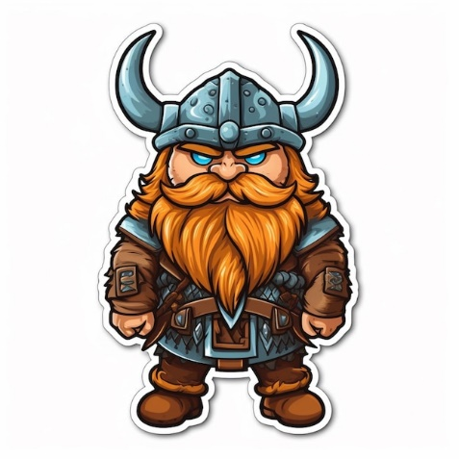
Vicious Viking Day

Tuesday 9th January 2024 was thrilling, dramatic, it was vicious, a day full of fascinating facts. It was Viking Experience Day – a day full of fun.

To fire off the day we marched into the hall to hear a welcoming speech by the actor Bjorn the Viking. He spoke very fast like a sports commentator at a football game. After, we acted out different Viking jobs, I enjoyed pretending to be a warrior capturing the Anglo – Saxons in AD 793. Following on, we returned to our class group to play some amazing activities in the hall. Whether it was wearing Viking clothes (I think I looked the best), rolling dice or even turning the Quern stone, they were all fun.
After break, we returned to our classes to play games, my favourite game was a board game called Nine Men’s Morris – a fast paced game where you had to get three in a row with your pieces. Time flew by with each activity and before you knew it, it was lunch time. Even though playing outside is fun, even though the school dinners are delicious, I still wanted to resume learning.
Finally, we got to one the best bits of the day. The Chainmail Challenge. There was one enormous, intimidating chainmail vest. I tried lifting it up and I just about managed. Imagine wearing that to battle!
Spears raising, shields blocking, loud chanting, even fiercer shouting was the sound that we heard when we acted out a Viking army charging in to battle. We were having a competition to see who was fiercer. It was Badgers vs Ravens. I was a Badger and we obviously won thanks to our fierce shield wall.
Unfortunately, all good things come to an end, as the clock struck three I realised learning can be fun, you just need to embrace it.

By Tony Owen Pinto
HB12

