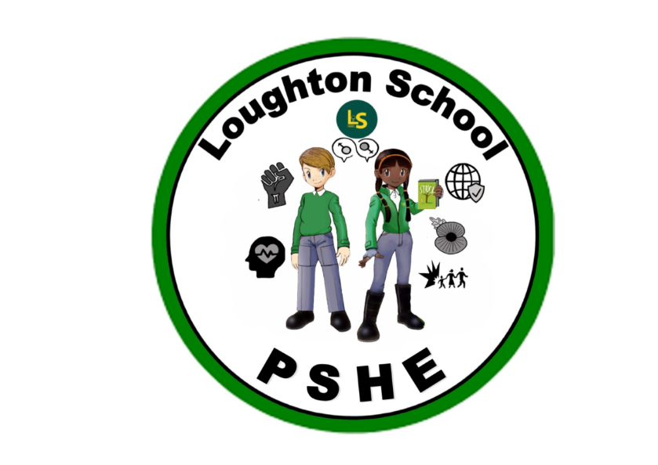
 | Autumn | Spring | Summer
LKS2  Year 3 | Amazing Animals  Online Safety  Technology, online safety, responsible, behaviour, reporting, content, contact  Black History month  Dilemma, citizens, civil rights, equal rights, heroine, boycott  Remembrance  Remembrance, symbol, dedicated, devoted,  Anti-bullying  Bullied, left out, unwelcome, refugee, war, kindness, friendship, unintentional, intentional  The role of money  Not planned yet | Kings and Queens  Celebrating diversity – SEND  Not planned yet  Heathy Relationships & SRE  Not planned yet  Safer Internet day  Not planned yet  International women’s day  Not planned yet  Earth hour and day  Not planned yet  Physical health  Not planned yet | We are Scientists  Money & Careers  Not planned yet  Mental Health and self-image  Not planned yet  Transition and change  Not planned yet  Celebrating success  Not planned yet
LKS2  Year 4 | From the Romans to modern day Italy  Online Safety, becoming a good digital citizen (building on year 3)  Respectful behaviour, acceptable/ unacceptable behaviour, digital citizen, social society, my networks, gaming groups, netiquette  Black History month  Culture, accomplishments, community, celebrate, difference, diversity, respect, opinions, human rights, rules, laws, segregation  Remembrance  To come  Anti-bullying  Qualities, bullying, sadness, different, gender, appearance, disability, imitate, unique, lonely, gang, popular, secret, proud, share  The role of money  Not planned yet | India  Celebrating diversity – SEND  Not planned yet  Heathy Relationships & SRE  Not planned yet  Safer Internet day  Not planned yet  International women’s day  Not planned yet  Earth hour and day  Not planned yet  Physical health  Not planned yet | Heroes and Heroines  Money & Careers  Not planned yet  Mental Health and self-image  Healthy mind, brain, self-image, positive, healthy body, feelings, happiness, emotions, worried, upset, meditation, smiling, sorry, kindness, embarrassed, good manners, sharing  Transition and change  Not planned yet  Celebrating success  Not planned yet
UKS2  Year 5 | The world around us  Online Safety including online identity (building on year 4)  Online identity, protect, personal privacy, wellbeing, range of reporting methods  Black History month  Race, ‘people of colour’ ethnicity, religions, declaration, government, MP, constituency, liberty, freedom  Remembrance  Somme, war memorial, commemorate, civilians, cavalry  Anti-bullying  bullying, imbalance, power, preventing, responding, discrimination, refugee  The role of money  Not planned yet | Vikings  Celebrating diversity – SEND  Not planned yet  Heathy Relationships & SRE  Not planned yet  Safer Internet day  Not planned yet  International women’s day  Not planned yet  Earth hour and day  Not planned yet  Physical health  Not planned yet | Understanding me  Money & Careers  Not planned yet  Mental Health and self-image  Not planned yet  Transition and change  Not planned yet  Celebrating success  Not planned yet
UKS2  Year 6 | From Darkness to Light  Online Safety including social media (building on year 5)  Social media, rights, information invasion, connect, collect, communicate, digital friendships, sharing, phone etiquette, cyberbullying, bystander, online addiction, cyber strangers.  Black History month  Celebrate, achievements, contributions, educate, influenced  Remembrance  Remembrance Day, lest we forget  Anti-bullying  bullying, imbalance, power, preventing, responding, physical, relationship, teasing, ‘banter’, abuse, cyber bullying, anonymous, social networking, prejudice  The role of money  Not planned yet | Natural vs Supernatural  Celebrating diversity – SEND  Not planned yet  Heathy Relationships & SRE  Not planned yet  Safer Internet day  Not planned yet  International women’s day  Not planned yet  Earth hour and day  Not planned yet  Physical health  Not planned yet | The Americas  Money & Careers  Not planned yet  Mental Health and self-image  Mental health, feelings, hormones, neurotransmitters, adrenaline, oxytocin, cortisol, serotonin, dopamine, depression, sadness, anxiety, relaxation, mindfulness, fixed mindset, growth mindset, change, peer pressure, peer influence, organisation  Transition and change  Celebrating success  Not planned yet

