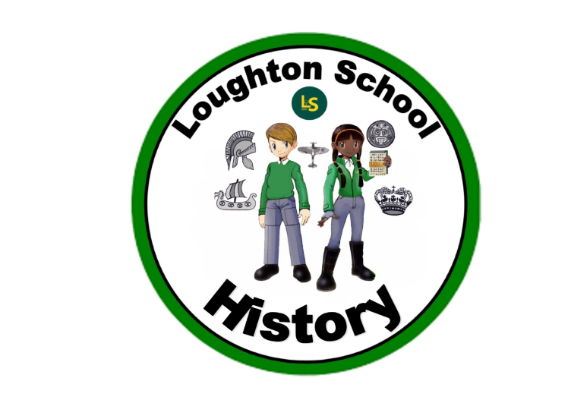
 | Autumn | Spring | Summer
LKS2  Year 3 | Amazing Animals  No history taught during this theme. | Kings and Queens  Historical periods, British, chronological, trends, contrasts, monarchs, crime, punishment, court, century, fought, battle  Through guided reading…  Isolation, convoy, hated, companionship, adored, independence, succession, captivates, thronging, benevolence, desolate, sovereign, humblest  Heir, famously, divorce, monk, settled, honour, execution, maiden, archaeologist, regal, coronation, antique, state, throne, non-fiction | We are Scientists  Events, beyond living memory, significant people, chronological, constructed, connections, trends, contrasts.

LKS2  Year 4 | Italy  Sources, chronological, BC, AD, BCE, Celts, tribe, chief, hillfort, torc, woad, chariot, Iron Age, Gauls, Britons, Gaels, settlements, Britannia, Caledonia, Iceni, Boudicca, Romans, legion, defeated, emperor, cavalry, ancient, empire, conquered, conquest, timeline, map, rebel, kay events, caster, chester, territones, military, soldier, army, legionaries, Latin, battle, uniform, spear, shield, helmet, armour, cassis, scutum, gladius, caligae, pilum, lorica segmentata, tunica, focale, tortoise, onager, war, ballista, battering-ram, formation, war machines, Hadirian’s wall, fort, barbarians, Rome, Pompeii | India  No history taught during this theme. | Heroes and Heroines  Change, cause, similarity, difference, significance, knowledge, constructed, sources, primary, secondary, impact
UKS2  Year 5 | The world around us  Chronological, sources, interpret, evaluate, evidence, biographies | Vikings  Chronological order, timeline, era, period, transport, traders, raiders, explorers, navigation, deities, Norse Gods, archaeological digs, invasions, theories, long boats, oral storytelling, Viking runes, food, clothing, travel, long houses, artefacts, primary, secondary. | When I grow up…  No history taught during this theme.
UKS2  Year 6 | From Darkness to Light  World war II, chronological, code breaker, enigma, codes and siphers, enemy occupation, significant, commanders, rationing, evacuation, air raid, Anderson shelters, blackout, Battle of Britain, Dunkirk, allies, axis, dictator, fascism, democracy, Blitz, propaganda | Natural vs Supernatural | The Americas  Civilisation, Maya, artefacts, irrigation, drainage, hieroglyphs, codices, stelae, trade, city-states, temples, rulers, nobles, freemen, slaves, Mesoamerica

