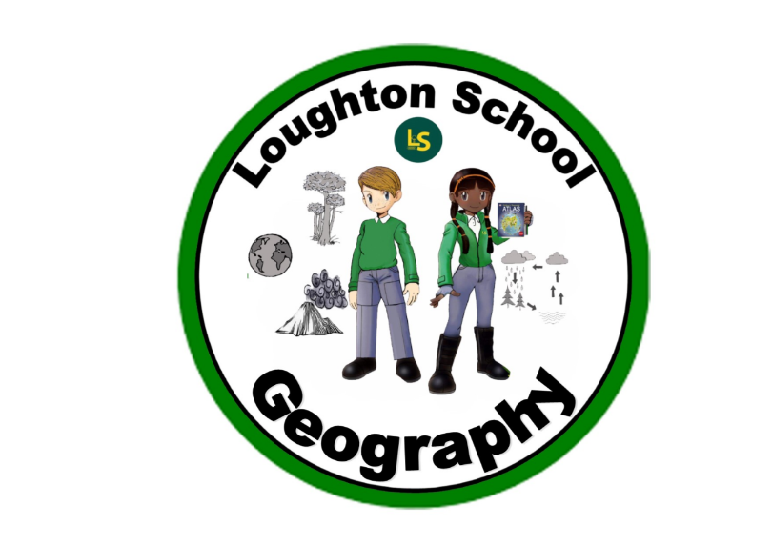
 | Autumn | Spring | Summer
LKS2  Year 3 | Amazing Animals  Continents, Asia, Europe, Africa, North and South America, Antarctica, Oceania, countries, physical, human characteristics, weather, climate, geographical, position, atlas, latitude, longitude, map, equator, Northern and Southern hemisphere, Arctic and Antarctic circle, North, South, East, West, North-East, North-West, South, South-East, South-West, Cardinal.  Fieldwork: Village, route, scale, direction, population, navigation. | Kings and Queens  Continent, country, city, United Kingdom, commonwealth, empire, Buckingham Palace, Tower of London, fort. | We are Scientists  Equator, Northern and Southern Hemisphere.  ROCKS AND SOILS:  Igneous, Sedimentary, Metamorphic, marble, chalk, granite, fossil, magma.
LKS2  Year 4  and words taught in year 3. | Italy  Map, caster, chester, Hadrian’s wall, tourism, tourists, volcanoes, Italy, dormant, extinct, crust, lava, magma, mantle, eruption, active, world, oceans, seas, Naples, pyroclastic, flor, cone, igneous, tectonic plates, flow, fissure, core (inner and outer), formations, form, chambers, mountains, landscape, weather, climate, valleys, peaks, fort, hillfort, atlases, Europe, continent, countries, hamlet, village, town, city, amenities, services, aqueduct, empire. | India  Continent, country, India, Northern hemisphere, River Ganges, Thar desert, Himalayan mountains, Mumbai, Arabian sea, Bay of Bengal, tectonic plates, compass points, physical and human features, geographical features, compare, settlement, rich, schooling, climate, weather, monsoon, lifestyle, population, dispersed and scattered settlements. | Heroes and Heroines  (Maths)  Position, direction, turn, North, South, East, West.
UKS2  Year 5  and words taught in year 3 & 4. | The world around us  Continent, country, rainforest, deforestation, climate, seasons, current affairs, climate change, tropical, oceans, campaign, globe, reduce, reuse, recycle, plastic pollution, polar ice caps.  Earth, space, spherical. | Vikings  Hemisphere, settlements, Lindisfarne, longitude, latitude, continent, ocean, Northern Europe, Scandinavia, fiords, mountain, valley, map (modern and historical), nomads, navigation, terrain, Norway, Sweden, Finland, Denmark, Baltic Sea, North Sea, political, topographic, climatic, physical, equator, Greenwich meridian, Earth’s grid. | When I grow up…  Flowering, non-flowing plants, surrounding area
UKS2  Year 6  and words taught in year 3, 4 & 5. | From Darkness to Light  Invasion, continent, country, map, Europe, Germany, Britain, Soviet Union, Bletchley Park, Battle of Britain. | Natural vs Supernatural  Kingdom, environmental factors, climate, habitat, desert, farmland, alpine, arctic, tundra, ecosystem, fossil, sedimentary, igneous, metamorphic, Jurassic coast. | The Americas  River, biome, desert, steppe, tundra, temperate, tropical rainforest, taiga, flood plain, estuary, source, tributary, oxbow lake, delta, meander, civilization, The Americas, continent, globe, atlas, desert, mountain, river, longitude, latitude, equator, Greenwich Meridian, equator, climate, The Amazon river, the Atacama Desert, Cape Horn, the Andes Mountains, Niagara Falls, Yellowstone National park, Mississippi River, Death Valley, Earthquake, tectonic plates, Ring of Fire, Cherokee Tribe.

