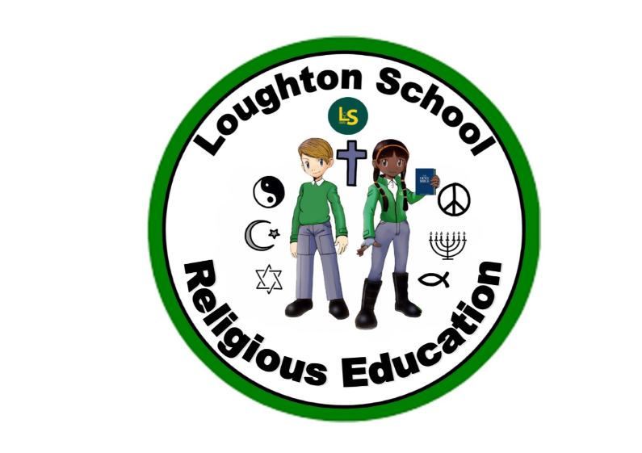
 | Autumn | Spring | Summer
LKS2  Year 3 | Amazing Animals  Christianity - Christmas  advent, traditions, Jesus, light of the world, holiness – halo, angels, candles, advent candles, star, Christingle, stable, guiding light | Kings and Queens  Buddhism  Buddhists, Siddhartha Gautama, eight-fold path, noble truths, karma, symbols, connections, teachings, religion, statue, shrine  Christianity – Easter | We are Scientists  No RE taught during this theme.
LKS2  Year 4 | Italy  Christianity - Christmas  journeys, Mary, Joseph, Jesus, spiritual, direction, milestones, Bethlehem, angel Gabriel, pilgrimage, shepherd, wise men, king, gifts, symbols, objects, Gold = royalty, Frankincense = sinless life, Myrrh = his sacrificial death, Herod, home, homelessness | India  Hinduism  Hindus, faith, respect, worship, Gods, Goddesses, sacred text, puja, festivals, tolerance, belief, Brahma, Vishnu, Ganesh, Krishna, Lakshmi, Shiva, Rama, Sita  Christianity – Easter  spring time, traditions, celebrations, festivals, service to others, maundy money, Palm Sunday, meal, serve, Garden of Gethsemane, emotions, disappointment, crucifixion | Heroes and Heroines  No RE taught during this theme.
UKS2  Year 5 | The world around us  Christianity – Christmas  peace, refuge, refugees, baby, families | Vikings  Christianity – Easter  Betrayal, death, resurrection, synagogue, Jewish, disciples, Gethsemane, Passover, Peter, denial, prediction, crucifixion, anointed, Galilee, charismatic, resolute, loyalty, mosaic law, courage, faith, refute, Pentecost, imprisoned, martyr | When I grow up…  No RE taught during this theme.
UKS2  Year 6 | From Darkness to Light  Islam  Muslims, qu’ran, Imran, mecca, five pillars, Allah, mosque, Mohammed  Christianity - Christmas  Believe, belong, behave, incarnation, worship | Natural vs Supernatural  Christianity – Easter  resurrection, celebration, death, new beginnings, treasure, joy, happiness | The Americas  No RE taught during this theme.

