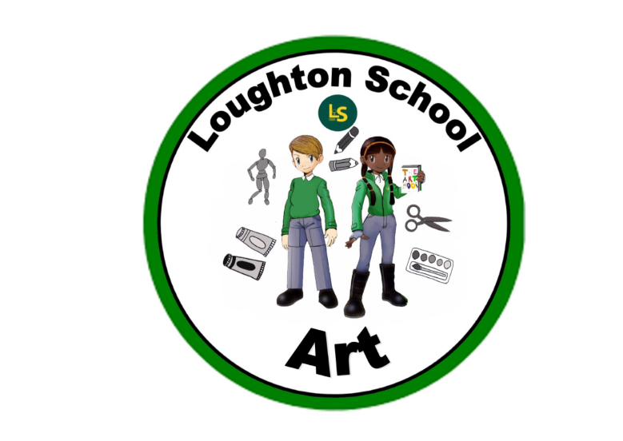
 | Autumn | Spring | Summer
LKS2  Year 3 | Amazing Animals  Perseverance, trying, attitude, resilience, feint, pressure,  Colours -Primary, secondary, complimentary, opposites, blending, mixing.  Shades, tones, tints, gradation,  Blending, colour, outline, shading, shadows, features.  Smooth, surface, impression, imprint, fold, carve, pinch  Natural materials, glue, hot glue, template, cut, join, colour choices, googly eyes, character  Pearlescent, coverage, colour choices, design  Template, construct, texture, glue, scissors, snip, cut, trace, modify, copy  Painting with scissors, cutting, shaping, sticking, | Kings and Queens  Stick figures, positioning, model, mannequin, form, line, fleshing out, movement, direction, proportion  Embroidery, stitches, pattern, story, thread  Template, printed papers, fabric, texture, colour choices, complimentary colours, tracing paper, trace, opaque and translucent, design, historic, accurate, form fitting, fashion, cutting, shaping  Oil pastels, cubism, Picasso, irregular, symbolic, representation  Anatomy, skull, features, symmetry, oval, pencil strokes, drawing frame, shape, line, form.  Portrait, regal, clothing, jewellery, crown, fashion  Proportion, symmetry, outlines, likeness. Blending colours, mixing, watercolour, palette. | We are Scientists  Wax resist, colour wash, palette, mixing, watercolour, blending, waterproof  Skills , hatching, blending, cross hatching, pressure, neat, careful. Paul Klee  Composition, positioning, drawing what you see, detail, miniature, reduction,  Blending, shading, hatching, smudging, template, bold  Light, photons, ribbons, spectrum, radiation, blending, swirl, ethereal, visible, dancing, silhouette, backlit, aurora, colours, blending, pastels,  Glass nuggets, magnification, shrinking, detail, features, mini-beasts, glue, stick, mount
LKS2  Year 4 | Italy  Triquetra,Celts, pattern, symmetry, ombre, sequential, endless  Shades and tints, blend, mix, paint technique  Obverse, reverse, heads, tails, forge, profile, features, likeness,  Smooth, shape, carve, design, simplicity, numerals, metallic, depth, pressure, coverage, shine.  Tiles, design, composition, pattern, repeated, geometric, random, expense, historic, long-lasting. Grid, colour, shaping, outline, curve, glue, grout, background, foreground, object, shading, | India  Architecture, sepulchre, outline, façade, supports, form, line, shading, carving, texture, skyline, dome, proportion, perspective, reflection, veneer. Outline, vivid, vibrant  Pattern, shape, repeated design, swirl, scroll, freehand, symmetry, motif, body painting, floor painting, colours, paint, mixing, colour choices,  Man-made, natural, motif, geometric, mirror image, invert, reverse, drawing frame, half frame repeat, offset, size, colour, diagonal, checkerboard  Print, brayer, pull, roller, block, polyprint, ink, layer, negative image | Heroes and Heroines  Famous artists, inspirational, pushing boundaries, looking at things in a new way, O’Keeffe, Monet, Warhol. Magnified, simplified, impressionist, realist, pop art, printing, collage, mixed media, popular, commercial, large, painted papers, origami, cutting out, folding, cartoon, realistic, bold, complimentary
UKS2  Year 5 | The world around us  Pencil strokes, weight, feint, light source, shadow, shading, shadow, hatching, cross hatching, dark, blend, gradient, shiny, 3-D, shapes, charcoal, burn  Background, middle ground, foreground, sphere, shading, outline, 3-D, collage, composition, design, inspiration, recycle, reuse, repurpose, laminate, paint, random, abstract shadow, shading, blending, graduate, illustrator.  Mental health, perception, visual, imagined, movement, beauty, light, shadows, foreground, distance, perspective, stylised, vibrant, bold, starry night, style, post-impressionist, impasto | Vikings  Painted papers, work stations, process art, collage, wax resist, stamping, printing, sgraffito, craftsmen, carving, masthead, mascot, symmetry, symbols, design, colour  Human body, form, proportion, fashion, historical, embellished, fabric, texture, review techniques  Clay, form, mould, shape, smooth, carve, dig, form, pupil, iris, scales, skin, paint, colour theory, pearlescent, complimentary  Sewing, binca, thread, eye, point, stitch, pull, pattern, rune, stem, diagonal, border, embroidery, floss | When I grow up…  Changes, wrinkles, texture, definition, expression, character, “Draw light till you know it’s right” pressure, shading, light source  Printing—ink, pressure, polyboard, imprint, negative and positive image, pulling a print, brayer.  Drawing human form, correct proportions, positioning, mannequin, line, movement, silhouette, shadow, outline.  Cutting, gluing, mounting, collage, mixed media, multi-media, composition.  , shadows, shading—smudging, cross-hatching, hatching, weight of pencil strokes, direction, likeness, shape, drawing what you see, copy, symmetry  Doodle, printing, stamp, ink pad, line, form, creative, small, character
UKS2  Year 6 | From Darkness to Light  Shading, 2D-3D, light source, shadows, depth of tone, gradient, reflections, shiny surface, softness of pencil,  Outline, line, form, shape, symmetry, proportion, perspective, direction, movement. Background, foreground, detail, fade, smudge, blend, texture  Armature, tape, build, proportion, symmetry, extend, skeleton, form, mould, compress, wrap, shape, cover.  Exothermic reaction, irreversible changes, wetting, moulding, smoothing, plaster of Paris, resin, setting, drying, firm, hard, coverage, cover, conceal, layers, residue, slimy, evaluation.  Paint mixing, colour choices, camouflage, decals, PVA covering, layers, shine, seal  Skyline, historic, buildings, architecture, silhouette, line, form, distance, perspective, nearground, background, colour mixing, blending, fading. Cutting, sticking, trimming,  Blending, form, light source, colour choice, shadows, highlight, oil pastel | Natural vs Supernatural  Sketching, drawing with our eyes, observational drawing, armature, bones, fleshing out, pose, roundness, proportion, head height, ratio, elbow, knee, shoulders, neck,  Pose, position, outfit, mannequin, representation, shade, tone, outline, marker  Perspective, vanishing point, near point, background, horizon line, guidelines, 3-dimensional  Cityscape, skyline, architecture, shape, line, form, silhouette, pattern, buildings,  Careful drawing, light strokes, shape, form, line, tone, hatching, close together, blend, smudge, gradient, imagination, size, composition  Brushes, wake up the paints, mixing, colour, light and dark, tone, shade, tint, wet paper technique, bleed, blend, flow  Foil, fold, feather, snip, shape, mould, join, bend, smooth, ruffle, proportion, texture, strength, cut, scissor action, careful, sharp | The Americas  Tome, day sign, numbers, represent, animal, draw, outline, colours, cut, glue, build, spin, split pin, size, proportion, spacing, divide  Plan, draw, symmetry, human form, fitting, fixing, attachment, depth, colour choices, paint, pearlescent, mixing, palette, neat, one direction, complimentary colours, colour theory, carve, mould, death, battle, celebration, persona, symbolic  Plan, draw, symmetry, simplify, shrink, Shrinkles, heat, thermoplastic, reduce, design, colour, simplicity, trace, outline, colour, pierce, thread, knotting

