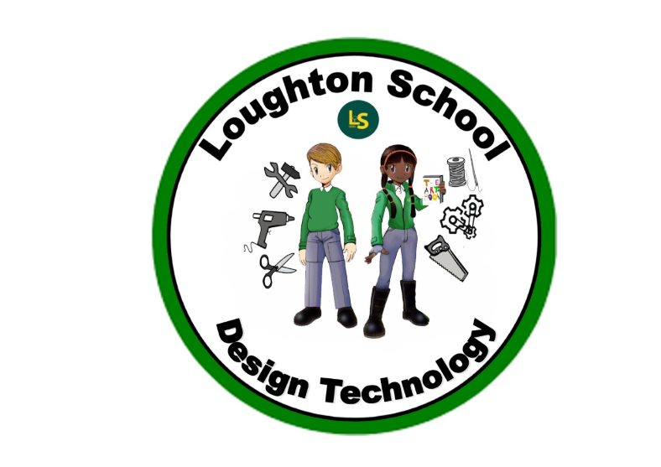
 | Autumn | Spring | Summer
LKS2  Year 3 | Amazing Animals  Sewing, needlework, puppet, materials, textiles, components, functional, aesthetic, properties, qualities, prototype, design, evaluate | Kings and Queens  No DT taught during this theme. | We are Scientists  STEM  mechanical systems, buggy, carriage, wheels, axels, build, reinforce, structure, tools, equipment, saw, hot glue gun, design, evaluate, improve, critique
LKS2  Year 4 | Italy  Food, health and safety, nutrition, pizza, dough, margherita, fresh, ingredients, authentic, pizzaiolo (pizza chef), smell, taste | India  Food, health and safety, nutrition, recipe, measure, ingredients, accurate, guidelines, prepare, evaluate, curry, naan bread, rice, feast, spices | Heroes and Heroines  STEM  mechanical systems, propeller, plane, explore, design, equipment, saw, hot glue gun, design, evaluate, improve, critique

UKS2  Year 5 | The world around us  Food, health and safety, nutrition, recipe | Vikings  No DT taught during this theme. | When I grow up…  STEM  mechanical systems, simple series circuits, pulleys, wheels, axels, barring, buggy, build, reinforce, tools, equipment, saw, hot glue gun, design, evaluate, improve, critique
UKS2  Year 6 | From Darkness to Light  Planning, construction, design, papier-mâché, recycled materials | Natural vs Supernatural | The Americas  STEM  defining problems, constructing, designing, solutions, evaluating, tools, techniques, cause and effect, communicate, brainstorm, record, testing

