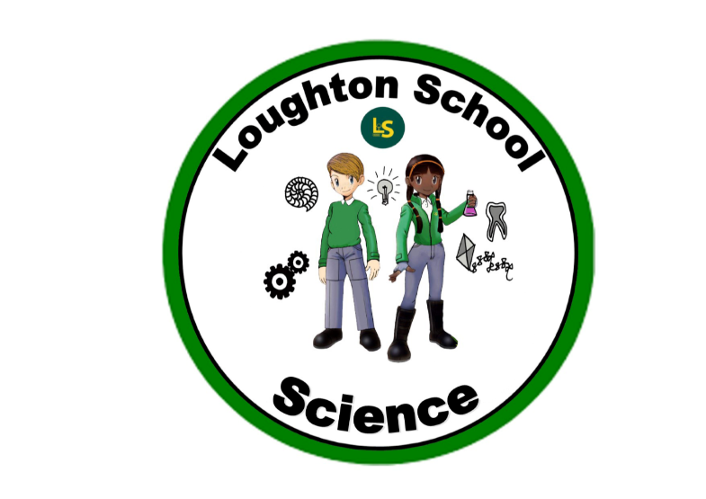
 | Autumn | Spring | Summer
LKS2  Year 3 | Amazing Animals  Skeletons, muscles, support, protection, movement, body parts, grouping, observing, exploring, contrast, teeth, incisors, canine, pre-molar, molar, herbivore, carnivore, omnivore, skull bone, cartilage, joint, relax, contract, vertebra/e, chew, tear, rip, grind, gnaw, cavity, decay, plaque, bacteria  Seeds, plants, roots, stem, leaves, flowers, healthy, air, light, water, nutrients, soil, room to grow, transported, life cycle, pollination, seed dispersal, seed formation, structure, function, reproduction, compare, factors, fair test, prediction, germination | Kings and Queens  Travel, push, pull, twist, friction, stretch, speed, movement, Newton, rough, smooth, North, South poles, magnetic, prediction, variables. | We are Scientists  Rocks, metamorphic, sedimentary, igneous, grains, crystals, soil, slate, granite, properties, layers, core, magma, earthquake, durability, fossil, fossilisation, observations, experiment, texture, appearance, permeability, acid, alkaline, organic, microscope, pumice, granite  Force, magnets, repel, attract, pole, North, South, transparent, translucent, opaque, absence, light energy, source of light, blocked, shiny, reflective, moon, sun, natural, reflectors, visible, shadow, mirror, investigation

LKS2  Year 4 | Italy  solids, liquids, gases  flaura, fauna, wildlife, habitat  evaporation, condensation, reversible, irreversible, boiling, freezing, water cycle | India  Environment, change, classification, living things, habitat, adaptation, interpret, construct, food chain, observe, record, producer, consumer, predator, prey, classification key, vertebrates, invertebrates  (Pre-cursor to year 5) | Heroes and Heroines  Electricity, appliances, mains, series circuit, components, conductor, insulator, wire, batteries, cell, bulb, lamp, switch, buzzer, motor  Oesophagus, stomach, digestion, saliva, tongue, nutrients, fat, protein, carbohydrate, small intestine, large intestine, bolus
UKS2  Year 5 | The world around us  Solar system, planets (inc. names of), orbit, spherical, axis, day, night, seasons, horizon, rotation, revolution, tilting, degree, anti-clockwise, East, West, sunrise, midday, sunset, equator, north hemisphere, south hemisphere, north pole, south pole, gravity, star  Force, resistance, air, water, friction, mechanisms, levers, pulleys, gears, effect, movement, fair test, newtons, gravity, pull, push, twist, stretch, reaction, compression, speed, velocity  Materials, properties, hardness, solubility, transparency, conductivity, response to magnets, dissolve, liquid, solid, mixture, separation, filtering, sieving, evaporating, changes of state, reversible changes, irreversible changes, burning | Vikings  Local, wider environment, identify, group, classify, living things, impact, adapt, interpret, construct, food chain  (Building on from introduction in year 4)  Magnetic, Transparent, Permeable, Absorbent, bulb, battery, wire , open, closed, cell, conduct, insulate, light, Opaque, Transparent, Translucent,  Evaporate, Solute, Solution, Solvent | When I grow up…  Life cycles, mammal, amphibian, insect, bird, life processes, reproduction, plants, animals, humans, change, development, gestation, compare, observe, reproductive, sperm, egg, fertilization
UKS2  Year 6 | From Darkness to Light  Electricity, circuit, bulb, cell, battery, switch, wire, motor, buzzer, component, electrode, cathode, anode, electrolyte | Natural vs Supernatural  Characteristics, variation, inheritance, offspring, identical, adaptation, environment, analyse, cladogram, natural selection, classification, micro-organisms, fungi, lichen, habitat, breath, reproduce, excrete, similarities, differences  Heart, lungs, blood vessel, artery, vein, aorta, capillary, oxygen, carbon dioxide, chamber, atrium, ventricle, double circulation, trachea, bronchus/bronchi, bronchiole, pulse | The Americas  Adaptation, evolution

