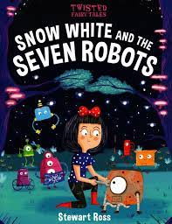
This week HB5 have based their work on the book ‘Snow White and the seven robots’. We have looked at how the story is different compared to the original story. We have thought a lot about the fairy tales we grew up reading and created our own version of a twisted fairy tale.
As the story involved robots, we also designed and created our own moving robot puppet. The children worked hard making a prototype and writing a set of instructions robot before making their final piece. The class were very eager to show off their individual robots.
Miss Garner and Miss Brago

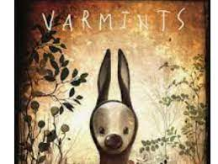
HB6 has based this week’s work around the book ‘Varmints’. Children have used this story to write character and scene descriptions.
In groups, the children held a debate about some of the issues from the story. For Example: ‘humans destroy the countryside and all the animals disappear’. For the art activity, children produced fantastic silhouette pictures of the tall tower blocks. Towards the end of the week, children created their own stories making up their own varmint characters and their own adventures.
Mrs Newman

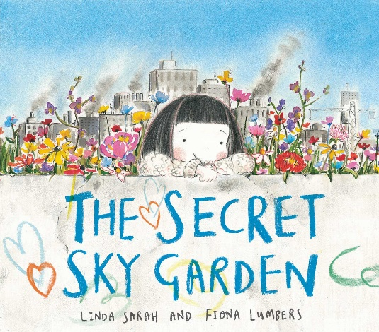
HB7 have based this week’s work on ‘The Secret Sky Garden.’ We have been creating excellent sentences in English focusing on description. The book focuses on looking after the environment and the importance of friendship.
As the story involved creating a garden, we have been creating our own origami flowers. All children were successful in creating their own flowers and were very proud of their final creations. As an extra experience, we have grown cress in our classroom to inspire the children’s gardening skills.
Miss Carter

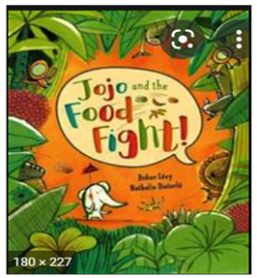
HB8 have based this week’s work around the book ‘Jojo and the Food Fight’. We have used the morals of this book of peace and friendship to reinforce the values of friendship and how we should work together as a class.
The food fight in the book involves a range of exotic fruits (mangoes, passion fruits, papayas, etc). For a food experience, the class had an afternoon of exotic food tasting. They had to describe the look, feel and taste of the fruits. Many experienced never tried fruits before and the activity was loved by all.

Mrs Ruggles

