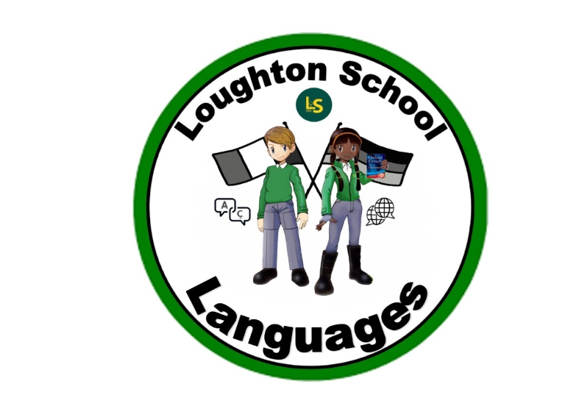
 | Autumn | Spring | Summer
LKS2  Year 3 | Greetings and colours  Good morning Good afternoon Hi Goodbye  I'm well I'm not well I'm OK  How are you?  My name is What's your name? and you?  circle triangle square  red green yellow blue purple orange pink white black grey brown  it is  What is it?  Which is your favourite colour?  Which colour is ___? | Birthdays and the body  January February March April May June July August September October November December  My birthday Happy Birthday  Is, in  I have years old  (the numbers 0-10)  I, you  How old are you? When is your birthday?  Head shoulders knees feet eyes ears mouth nose hand arms legs hair  I am a boy/a girl | Picnic and the Classroom  Bread jam chocolate biscuits apples bananas pears oranges orange juice picnic  I like I do not like  What do you like?  there is/are  exercise book folder pen pencil rubber sharpener ruler scissors glue whiteboard desk chair classroom  Classroom commands and requests
LKS2  Year 4 | All About me  Hot cold scared tired happy sad hungry thirsty  Gold silver  Your, my | The market and the farm  Animals cat dog horse pig cow sheep mouse bird duck hamster the farm  Fruit vegetables the market tomato onion strawberry cucumber potato grapefruit carrot lettuce euro  At, I would like  How much/many?  It's how much/many?  How much/many is/are there?  Big small  a/an/some, the | Around the World  I wear hat scarf shirt t-shirt trousers shorts jumper skirt shoes socks underwear jeans coat sunglasses dress clothing  Mum Dad brother sister aunt uncle cousin grandma grandpa twins, twin  if  with  What do you wear?  I go by (in/at/with) car bus bike train hot-air balloon boat rocket plane fast slow  Where are you going on holiday?  How do you get there?
UKS2  Year 5 | Food and Drink, and the Solar System  Cereal toast croissant (pastry) butter yoghurt egg coffee hot chocolate milk tea sandwich cheese ham crisps salad chips/fries Coca-cola Lemonade water apple juice fruit juice meat chicken pasta rice sausage hot dog ice cream burger mushroom salt and pepper sugar soup cake fish  I play I do/ I make I swim I dance I run  Basketball hockey football tennis cycling gymnastics hiking  I eat I drink healthy unhealthy delicious disgusting I have eaten I have drunk  very  for  because  The Solar System Mercury Venus Earth Mars Jupiter Saturn Uranus Neptune Pluto the Sun the Moon asteroid the stars  in/inside next to behind in front of under over/ on | Daily Routines and the City  Museum school café house bus stop post office park restaurant shop station hospital church shopping centre  Left right straightahead  the city taxi underground  I see  also  really  Monday Tuesday Wednesday Thursday Friday Saturday Sunday  Piano guitar flute drums clarinet violin trumpet cello keyboard accordion Pop music Rap music Rock music classical music folk music I listen  Morning I wake up I wash I get dressed evening afternoon I watch I sleep interesting  Boring loud calm/quiet brilliant slow fun  quite  then | Nature  it rains it snows sunny windy cloudy weather forecast it is good/bad grass rock sky  bridge road bush people lake air flowers stone  Spring Winter Autumn Summer  Tree the leaves  they are  north south west east center  umbrella/parasol sand sea bucket and spade lighthouse mountain cliff starfish shell seagulls dark  light/clear  they have
UKS2  Year 6 | School and the wider World  we start we finish breaktime lunchtime assembly the subjects English Maths Science Theme Creative Arts French German P.E. Computing P.S.H.E. Art  funny  great  we have  our school has...  playground sports field toilets car park office classroom hall library The continents North America South America Antarctica Europe Africa Asia Oceania  the countries the USA Brazil South Africa India China Australia the UK France Spain Italy Germany Switzerland the Netherlands Belgium Austria Ireland  the ocean the forest the field the hill the island the world the landscape | Café Culture and Out and About  Delicacies, I would like, prices, you formal  (Language dependent) | Spanish Taster  Numbers, colours, food, greetings, animals, months, days of the week

